**Chemistry IA3**

**Can we really ditch fossil fuels?**

**Claim:** Petroleum is and always will be the best fuel

**Rationale:**

To produce energy from a fuel, a combustion reaction is required with oxygen to produce heat and another product. The general formula for a combustion reaction is:

Fuel + O2 → CO2 + H2O (Flexbooks.org, 2020)

The combustion reaction burns the hydrocarbon fuel source creating an exothermic reaction. For worldwide energy production, currently, 70% of all energy comes from non-renewable hydrocarbons. Hydrocarbons such as oil derivatives and coal have proven to be efficient and reliable sources of fuel, with the success of many developing third world countries being the easy access to advance, cheap fuel technologies (Transport vehicles, tractors, motors, etc) and an apparent abundance of cheap fuel. While developing countries are using these easily available resources to build their economies, many first-world nations, such as Australia, the United States, the United Kingdom, France, and many more that have stable economies have started to focus on preventing the damage caused by centuries of reliance on fossil fuels. Fossil fuel is the general term for any non-renewable hydrocarbon source, such as petroleum/gasoline which are oil derived, or coal. It is during the collection/ manufacturing/ refining and the eventual combustion of these finite fuel sources that toxic greenhouse gas emissions are created.

Energy production and consumption are currently the absolute worst sector in terms of greenhouse gas emissions (Ourworldindata.org, 2020). Greenhouse gasses are Carbon dioxide , Methane , Nitrous oxide , and sulphur hexafluoride (EPA.gov, 2023). These toxic gases are the reason why global climate change is occurring. These gasses create an effect known as the ‘Greenhouse effect’ in which radiation from the sun enters Earth’s atmosphere before reflecting off the crust and hitting the outer atmosphere filled with these toxic gasses, which act as a blanket preventing the radiation from leaving the atmosphere. This trapped radiation begins to bounce back and forth between the outer atmosphere and the crust, causing an ever-increasing heating effect on the Earth’s surface, working similarly to a garden greenhouse and thus the name. The increase in the percentage of carbon dioxide in the world’s atmosphere leads to climate change, and the rising global surface temperature in turn leads to an increased frequency and amplitude of natural disasters. The longer humans pollute the air with unnatural amounts of carbon dioxide, the closer to the ‘turning point’ humanity reaches (RMetS.com, 2021). The turning point is an estimated point where the compounding heat becomes irreversible and permanent damage to fragile ecosystems occurs. In a bid to stop this, many first-world nations have introduced laws to limit the amount of carbon they emit, in an attempt to safely transfer from a non-renewable grid and energy system to a sufficient and cost-effective renewable system. Many first-world nations have declared fossil fuels unfit for long-term sustainable energy production, and in turn, have started looking at cost-effective and viable renewable alternatives such as biofuels.

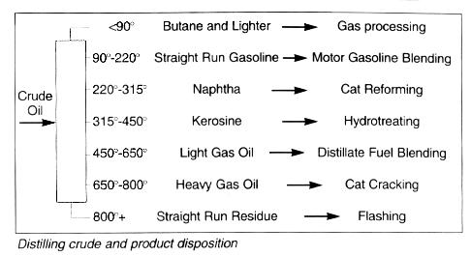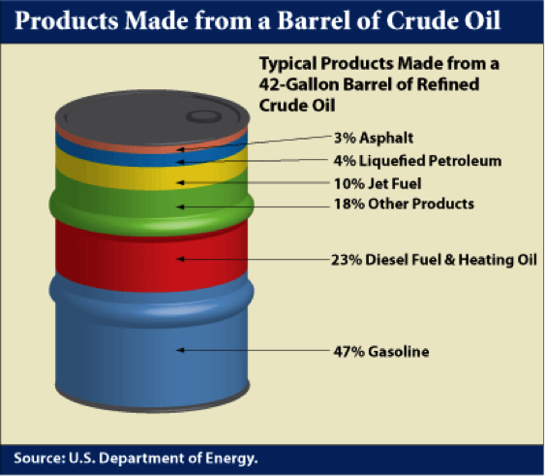

Figure 2 – Crude oil refining process

Figure 1 – Products from 1 Crude Oil Barrel

The world’s current dominant fuel source for automobiles is oil derived such as petrol and diesel. As shown in Figure 2, crude oil is refined through a long complex process of distillation, reforming, cracking, alkylation, isomerisation, polymerisation, and hydrotreating. This long process turns a barrel of crude oil into 47% petroleum, 23% diesel, and the rest into by-products such as jet fuel and petrochemical polymers as shown in Figure 1. There are currently approximately 700 oil refineries worldwide that produce the world’s supply of petroleum-based fuels.

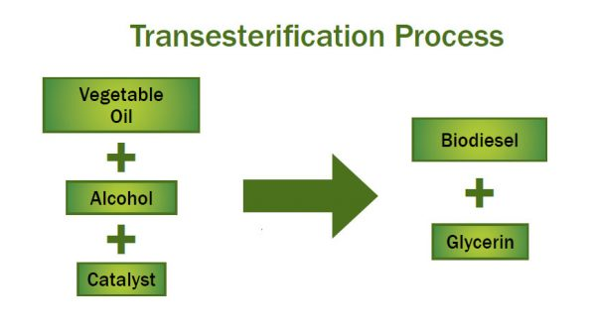Biofuel is the general term for any renewable fuel source (Energy.gov, 2023). The most common biofuels used for motor vehicles are ethanol and bio-diesel. Ethanol is an alcoholic organic compound that is most commonly produced from the fermentation of sugars and starch sourced from sugar cane and corn. In Australia, the most common use of ethanol is in E10 fuel, which is a combination of 90% petrol and 10% ethanol. E10 is currently the most popular biofuel as it has the highest possible ethanol percentage that the majority of existing petrol combustion engines can safely and efficiently handle. Other ethanol-infused fuels exist such as E85 which has between 70-85% ethanol. Unlike E10, E85 can only currently be used in a small number of specific engines due to being a newer technology which is mostly ethanol instead of standard petrol. A major limiting factor to ethanol is that it requires the specific growth of crops for ethanol production, creating the need to clear more land to still be able to sustain agriculture for the worlds growing population. While ethanol has some environmental factors to be worked out, biodiesel can be produced from waste oils and fatty acids.

Figure 7 – Transesterification process

Through the process of transesterification (shown above in figure 7), used cooking oil and fats react with alcohol and a catalyst to produce biodiesel and glycerine. Similarly, to ethanol, biodiesel is mixed in blends with standard diesel such as B10 and B20 which contain 10% and 20% biodiesel respectively. B100, 100% biodiesel also exists but similar to E85, only works in specialised vehicles (Biodiesel.org, 2023). In turn, this evidence has led to the creation of the research question.

**Research Question:**

Does ethanol generate less greenhouse gas emissions during the production/ manufacturing process and combustion phase compared to standard petroleum, and is the energy it provides comparable?

**Discussion of evidence:**

Many government sources claim that biofuels are the only viable solution to solving the climate crisis and global carbon emissions (Epa.gov, 2023). Biofuels are regarded highly as they have the ability to use existing technologies (Almost all modern engines) without requiring extensive internal (engine) modifications. Other innovative technologies such as electric cars have also become mainstream within the past 10 years but have faced issues such as the world not physically having enough minerals to replace all exists vehicles with current generation electric ones. While hydrogen cars are also getting some light of day, they will need more time to simply evolve and have their technology researched, and not to mention the enormous cost to setup and maintain and entirely new fuel distribution system across the world. This in turns leaves biofueled cars as the clear leader for current technology.

One of the major topics surrounding ethanol is the energy it can provide compared to standard unleaded 91. Comparatively, pure ethanol produces 30% less energy than petrol, which equates to 3% less energy within the standard E10 fuel mix. For consumers, the general cost of E10 is generally equivalent to standard unleaded petrol (afdc.gov, 2023). This had led to many consumers to speculate the usage of ethanol, as they have to pay more to drive the same distance for a small amount of environmental savings. The energy per litre becomes worse with the higher ethanol content. To reduce carbon emissions using ethanol, the vast majority of cars would need to be switched for newer ones to use higher ethanol contents to in turn burn less petrol. But the higher the ethanol content, the less energy is produced, for instance E85 has 27% less energy than standard petrol, leading to an even worse fuel economy and cost on consumers, not to mention that currently, E85 can only be used in purpose-built engines (afdc.gov, 2023).

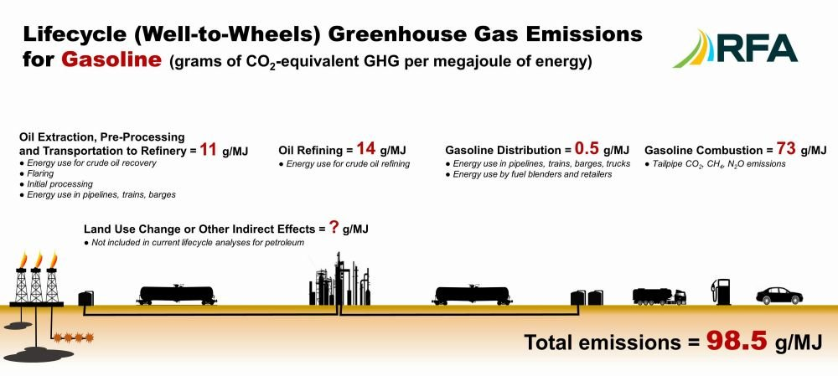Many sources claim that ethanol is completely carbon neutral. However, these studies fail to include the indirect emissions caused during the growth of the feedstock for ethanol production. Most ethanol feedstock crops, such as sugarcane, corn, and grains require extensive use of large machinery (that burn excessive amounts of diesel fuel), also not including the large amounts of petrochemical based fertilisers which themselves are by-products of petroleum refinery process. Another determining factor in the emissions generated by feedstock production is land clearance. While not entirely carbon neutral, researchers have found that the overall carbon emissions produced by ethanol is almost half that of standard fuel.

Figure 3 – Emissions for Gasoline (Petrol)

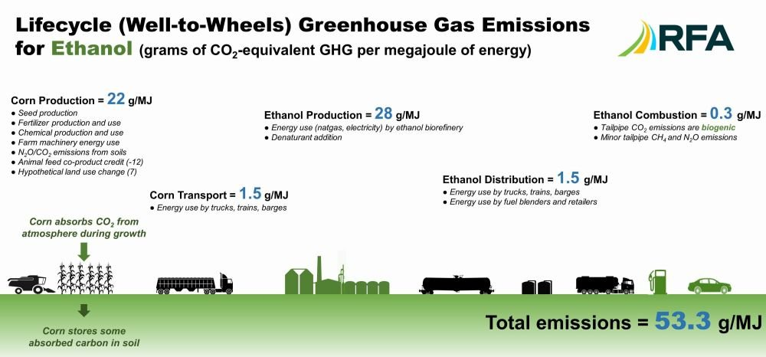

Figure 4 – Emissions for Ethanol

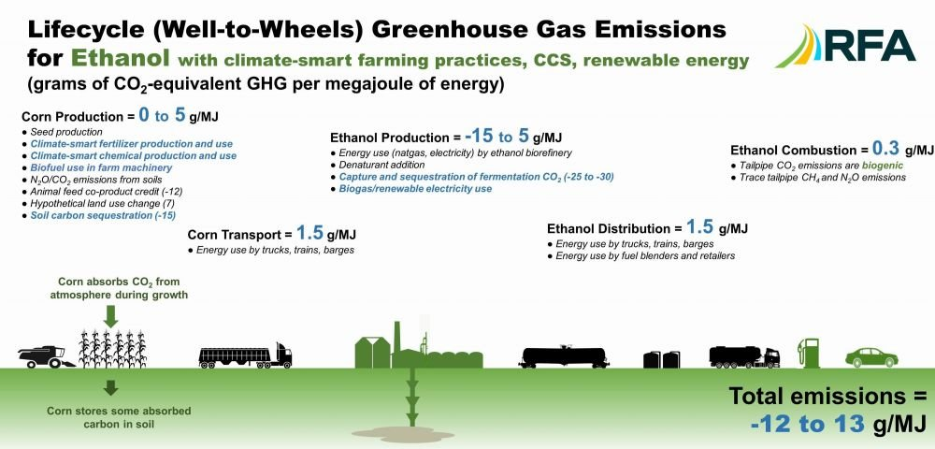It is shown above in Figure 3 & 4 that the majority of carbon emissions during current ethanol production comes from growth of feedstock and from the starch fermentation process. Throughout past debates, news outlets have used data cherry picking to compare the oil refining process in Figure 3 to the corn production process in Figure 4 in a bid to spread misinformation that ethanol was worse for the environment than standard fuel. It can be clearly seen above that total lifecycle emissions for standard petrol is 98.5g/MJ while ethanol emissions are almost half at 53.3g/ML.

Figure 5 – Emissions from Climate Smart Ethanol

Furthermore, improvements in farming techniques can result in even further carbon emissions reductions. Using green (sustainable and environmentally friendly) agriculture techniques can significantly reduce the carbon emissions during the feedstock growth process as shown in Figure 5. Figure 5 also highlights that it may not be entirely possible to reach zero or negative carbon emissions, but still highlights that ethanol is a much more sustainable long-term solution in regard to the environment, emitting between -12 and 13 g/ML of carbon dioxide. Figures 3, 4, 5 are all from the RFA, and independent reporting agency. The RFA is a credible source as their research clearly states where they are sourcing their data from and how each aspects interact with each other. Their reports are generated from a large array of publicly available and scientifically proven documents that clearly label their own limitations and any restraining factors.

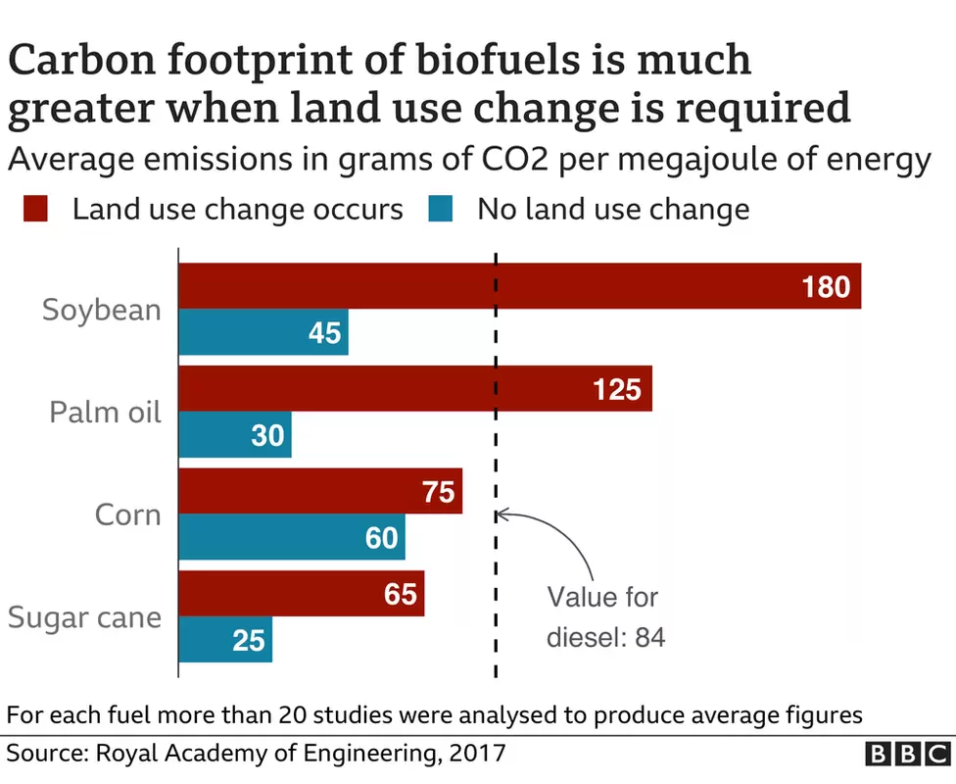The figures above demonstrate that ethanol is a ‘work in progress’ project for reaching net zero carbon emissions. But a determining factor in ethanol’s success will be the availability of already cleared farmland to grow feedstocks.

Figure 6 – Ethanol emissions due land clearing

Currently the majority of the world’s farm land is used for agriculture for human consumption. This in turn means that for the massive expansion and adoption of biofuel technology, large portions of land will need to be cleared in order to growth the appropriate food stock. With forests and grasslands currently being some of the most efficient ways to remove carbon from the atmosphere, clearing them in order to plant biofuel feedstocks defeats the purpose (Science.org, 2022). An article by the BBC referencing the Royal Academy of Engineering in figure 6 above displays that when land is cleared for biofuel plantations, the emissions for the energy produced are far higher than using existing land (BBC, 2021). This source is reliable as it is from the Royal Academy of Engineering and has used data from over 20 different studies.

**Conclusion:**

Therefore, from the data collected throughout this research investigation it can be concluded that ethanol will emit more carbon emissions than standard petrol during all stages of its life and the energy it currently produces is substantially less. The data shown in figures 3 and 4 shows current that carbon emissions from ethanol is only around half that of standard petrol. While both feedstock and crude oil have long complicated processes to be turned into their respective fuel sources, Figure 5 represents how the ideal ethanol production process would work. This however isn’t the case as it doesn’t factor in the need for extensive land clearing shown in figure 6. With the need to expand farmland for the purpose of biofuel feedstocks, it destroys natural carbon sinks and creates more lifetime emissions than just using standard petrol. Another determining factor in standard petrol being the current king of fuel is its reliability, availability and overall people’s common knowledge. While petrol is a finite resource and has its downsides on the environment, the significant economic effects of switching to quickly will be devasting on environment and consumers. Inconclusion, it can be determined that with further research into biofuels, specifically ethanol, newer and more environmentally sustainable methods of its productions can be developed. But until then, petroleum will remain as the world’s dominant automobile fuel source.

**Extensions:**

While the data collected for this report is all new, there can always be improvements and there will always be errors. To truly understand how much carbon is emitted from petrol and ethanol a much larger data collections experiment would need to be set up. This is because every country has varying efficiencies and procedures for the refining of oil and the growth of ethanol feedstock. The price at which existing and emerging technologies are based are also vital in determining the short- and long-term the success of these technologies and whether they are viable. With many third world countries still using and investing into generic combustion engines, it would need to be calculated how much carbon is actually being removed from the atmosphere and whether biofuels are the correct area to target to reduce emissions. The ideal data range would contain data from all possible methods and procedures used to generate all fuel types, as well as including their usage and their energy efficiency.

**Words: 1985**

**References (APA7):**

fortiain. (2012, August 16). Six good things about petrol. Forest Planet. <https://forestplanet.wordpress.com/2012/08/16/six-good-things-about-petrol>

tavo. (n.d.). Petroleum. Petroleum Equipment Institute. <https://pei.org/wiki_pei/petroleum/#:~:text=Due%20to%20its%20high%20energy>

Oil - Energy Education. (n.d.). Energyeducation.ca. <https://energyeducation.ca/encyclopedia/Oil#:~:text=Oil%20is%20particularly%20useful%20as>

CK-12. (2020, October 5). CK12-Foundation. Flexbooks.ck12.org. <https://flexbooks.ck12.org/cbook/ck-12-middle-school-physical-science-flexbook-2.0/section/5.22/primary/lesson/combustion-reactions-ms-ps/>

United Nations. (2022). What is Climate Change? Climate Action; United Nations. <https://www.un.org/en/climatechange/what-is-climate-change>

An Overview of Refinery Products and Processes | FSC 432: Petroleum Refining. (n.d.). Www.e-Education.psu.edu. <https://www.e-education.psu.edu/fsc432/content/overview-refinery-products-and-processes>

700 Refineries Supply Oil Products to the World. (n.d.). Retrieved June 7, 2023, from <https://hrcak.srce.hr/file/65010#:~:text=There%20are%20about%20700%20oil>

Australian Government. (2022). Ethanol (ethyl alcohol) - DCCEEW. Dcceew.gov.au. <https://www.dcceew.gov.au/environment/protection/npi/substances/fact-sheets/ethanol-ethyl-alcohol>

Center for Climate and Energy Solutions. (2017, November). Renewable Energy | Center for Climate and Energy Solutions. Center for Climate and Energy Solutions. <https://www.c2es.org/content/renewable-energy/>

United States Environmental Protection Agency . (2022, February 25). Global Greenhouse Gas Emissions Data. US Environmental Protection Agency. <https://www.epa.gov/ghgemissions/global-greenhouse-gas-emissions-data>

Ritchie, H., & Roser, M. (2020). Emissions by Sector. Our World in Data. <https://ourworldindata.org/emissions-by-sector>

Greenhouse gases and energy. (n.d.). Www.cleanenergyregulator.gov.au. <https://www.cleanenergyregulator.gov.au/NGER/About-the-National-Greenhouse-and-Energy-Reporting-scheme/Greenhouse-gases-and-energy#:~:text=The%20greenhouse%20gases%20that%20are>

Australian Institute of Petroleum. (2017). Refining of Petroleum | Australian Institute of Petroleum. Aip.com.au. <https://www.aip.com.au/resources/refining-petroleum>

U.S. Energy Information Administration. (2020, June 18). Ethanol explained - U.S. Energy Information Administration (EIA). Eia.gov. <https://www.eia.gov/energyexplained/biofuels/ethanol.php>

U.S. Department of Energy. (2019). Alternative Fuels Data Center: Biodiesel Production and Distribution. Energy.gov. <https://afdc.energy.gov/fuels/biodiesel_production.html>

U.S Department of Energy. (2019). Alternative Fuels Data Center: Ethanol Fuel Basics. Energy.gov. <https://afdc.energy.gov/fuels/ethanol_fuel_basics.html>

Cadogan, J. (2010, June 8). Ethanol Versus Petrol: The Basics. Drive. <https://www.drive.com.au/caradvice/ethanol-versus-petrol-the-basics/>

U.S Department of Energy. (2019). Alternative Fuels Data Center: Ethanol Benefits and Considerations. Energy.gov; U.S. Department of Energy. <https://afdc.energy.gov/fuels/ethanol_benefits.html>

Lenton, T. M. (2021). Tipping points in the climate system. Weather. <https://doi.org/10.1002/wea.4058>

Office of Energy Efficiency & Renewable Energy. (2023). Biofuel Basics. Energy.gov; Office of ENERGY EFFICIENCY & RENEWABLE ENERGY. <https://www.energy.gov/eere/bioenergy/biofuel-basics>

United States Environmental Protection Agency. (2019, January 29). Economics of Biofuels | US EPA. US EPA. <https://www.epa.gov/environmental-economics/economics-biofuels>

Machado, K. S., Seleme, R., Maceno, M. M. C., & Zattar, I. C. (2017). Carbon footprint in the ethanol feedstocks cultivation – Agricultural CO 2 emission assessment. Agricultural Systems, 157, 140–145. <https://doi.org/10.1016/j.agsy.2017.07.015>

Association, R. F. (n.d.). The Truth About Ethanol and Carbon Emissions. Renewable Fuels Association. <https://ethanolrfa.org/media-and-news/category/blog/article/2022/10/the-truth-about-ethanol-and-carbon-emissions>

Indonesia’s biodiesel drive is leading to deforestation. (2021, December 8). BBC News. <https://www.bbc.com/news/59387191>

‌ Biodiesel. (2016). Biodiesel Basics - Biodiesel.org. Biodiesel.org. <https://www.biodiesel.org/what-is-biodiesel/biodiesel-basics>

Bai, Y., & Cotrufo, M. F. (2022). Grassland soil carbon sequestration: Current understanding, challenges, and solutions. Science, 377(6606), 603–608. <https://doi.org/10.1126/science.abo2380>